### Lion Electric Co.

Stats

* 400+ ebuses out in service in 2021

About

* Supplies North America
* OEM, which makes all main parts as opposed to importing
* Located in Saint-Jerome, Quebec
* $350,000
* Up to 72 passengers
* Founded 5 years ago (oldest bus only 5 years old)

Electric School Buses

* Charging from 20% → 100% takes six hours
* Alarm alerts students when the bus is arriving because it does not make any noise.
* Electric trucks, school buses, ambulances, etc. (all electric vehicles)
* Low operation noise
* Will build a supplier in Joliet to build 20K buses in the summer of 2022
* Blue bumper indicates that the bus is electric
* School bus average lifetime is 12-15 years
* Grant department
* Electric school buses only have 400 parts whereas diesel has 3700 parts, meaning it is simpler.
* Can handle cold weather (built for Canada)
* [Tour](https://www.youtube.com/watch?v=AYh9S2hvgA8)
* Battery
  + 100% electric
  + Displays bus battery with three lights at top.
  + 66 miles on full charge
* Models

| LionC Electric School buses | LionA Electric School buses (smaller) |
| --- | --- |

* Will supply 1-25 school buses at a time
* Builds buses upon order (takes 9 months to produce/ship out)
  + Decide passenger count
  + wheelbase of 96” (city limit) or 102” (spacious)
  + Analyze routes for how long the bus travels (<100 miles, <150 miles, etc.)

### Blue Bird

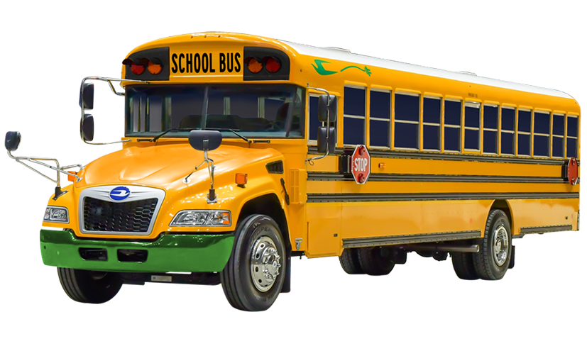

Stats

* 500 eschool buses as of July 2021
* Total revenue of 220 million
* 180,000 diesel & e buses
* 4 eSchool Buses in Suffolk County, Long Island. [Cost around $330,000 per bus according to Mr. Gallegher](https://stnonline.com/news/epa-grant-brings-electric-school-buses-to-new-york-district/#:~:text=Gallagher%20noted%20that%20since%20the,size%20of%20its%20electric%20fleet.)

About

* First electric bus builder in 1994
* OEM, which makes all main parts.
* Located in Georgia
* Founded in 1927
* Has >550,000 buses sold ever. Has longevity and reputation as American brand

Vehicle

* Have an electric version of the current bus we are using (blue bird vision).
* Gauge shows how efficient it is
  + Coasting
  + Accelerate slowly
* Regeneration electricity
  + Coasting turns the motor into a generator to recapture the motion into electricity
* Expects to have 100% of its sales from electric school buses by 2030
* Blue bird vision - class 7 car (Vehicle Weight Class)

Benefits

* Same seats, same safety, same body as diesel blue birds that Riverdale uses

### Thomas Built Buses (Jouley)

* Supplied Fairfax County, Virginia public schools
* V2G supplied from utility company, Dominion Energy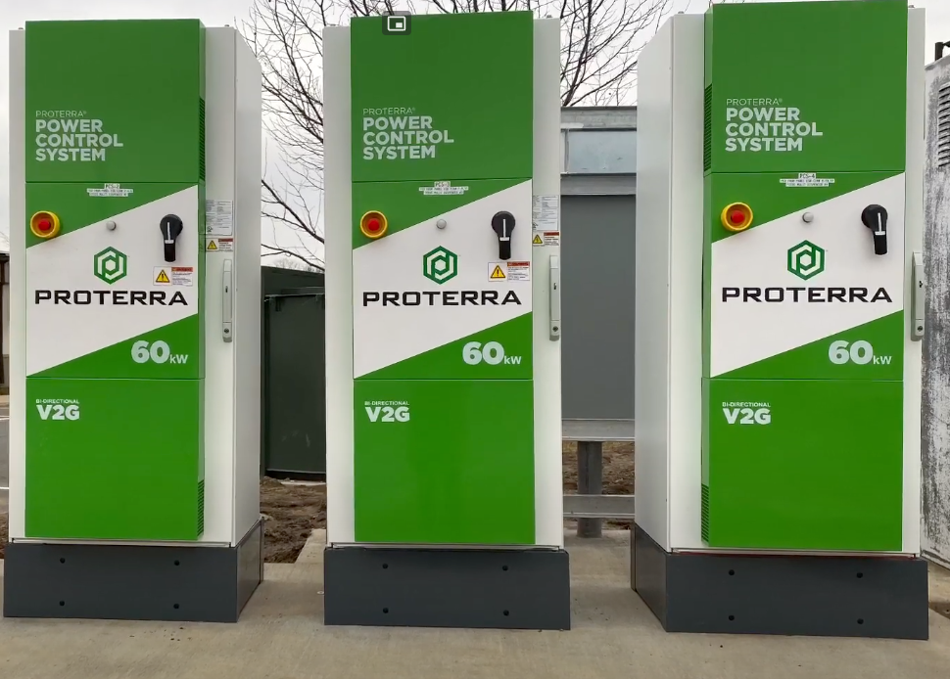
* Noise emitters in front and back
* Same gauges as diesel +battery info
* Riverdale uses
* 4 hour charging to full battery before running

How much are we talking about?

Interested in getting quote

List of incentives

Contact phone over Con Ed

[Matthew Buses](https://docs.google.com/document/d/1CqUD0POixUD5pL0ack3iSo038H4LqKh0uUGeBWtgQEc/edit?usp=sharing)

### NESCO

* 3 decades